
NEW! Flight Delay Service added to your
travel coverage

Real-time compensation when your flight is delayed

We're pleased to introduce Flight Delay Service, now included with your Medavie Blue Cross travel plan.

Flight delays can be stressful. This service is designed to help reduce the impact of unexpected disruptions by providing automatic compensation when eligible delays occur.

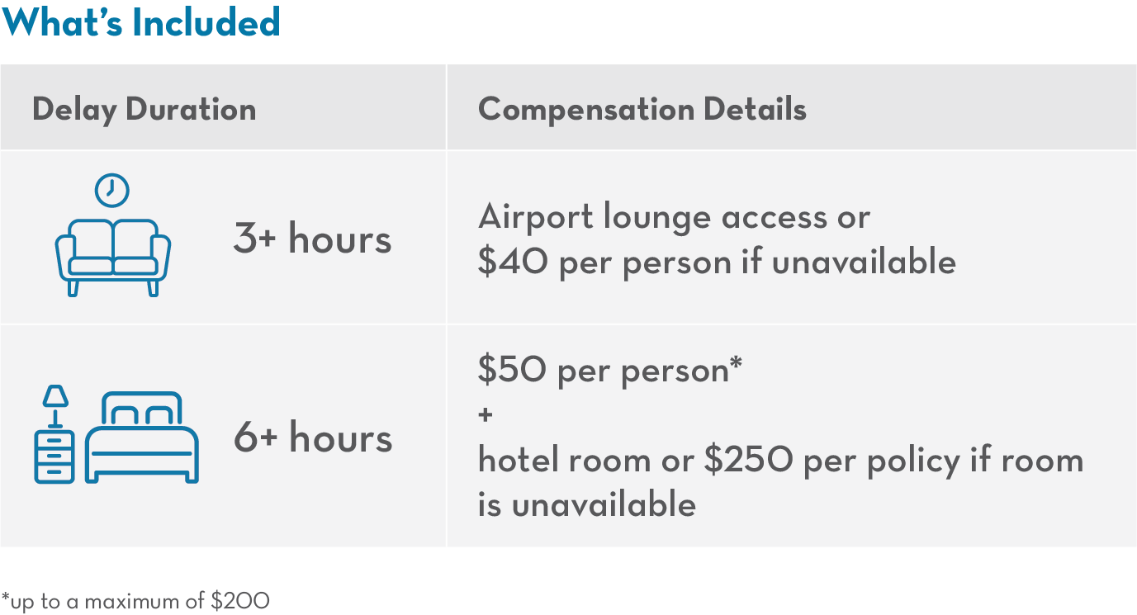

To activate this service, you must create a Flight Delay Service account and register your flight at least 24 hours before departure. Once registered, the service will monitor your flight and notify you by text message and email if a delay of at least 3 hours occurs.

To learn more and how to register, please log into the Member Services Site or open the Blue Cross Mobile app.

Get started today

Eligibility for this service varies by plan. Certain conditions, limitations, and exclusions may apply. Flight Delay Service is hosted externally. For security purposes, please use a unique password when creating your account.



